1. Create a form like below one.

1. Create a drop down menu bar like below one refer Syncfusion.com



1. Create a card like this

1. Create the following buttons

1. Create image view like this

1. Place the following icons in screen

1. Design training hub login page.
2. Design shopping cart page using bootstrap.

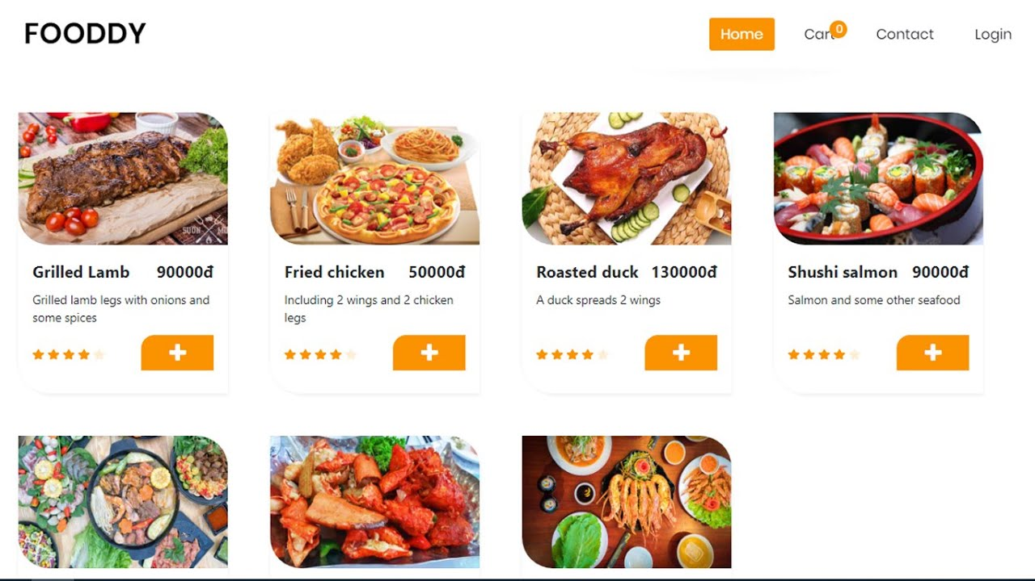

1. Design a side bar like this.

